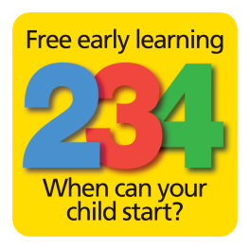

Who qualifies?
Parents who meet the following eligibility criteria:
- Income Support
- Income-based Jobseeker’s Allowance (JSA)
- Income-related Employment and Support Allowance (ESA)
- Universal Credit with an earnings threshold of £15,400 before tax
- Tax credits and you have an annual income of under £16,190 before tax
- The guaranteed element of State Pension Credit
- Support through part 6 of the Immigration and Asylum Act
- Working Tax Credit 4-week run on (the payment you get when you stop qualifying for Working Tax Credit)
A child can also get free early education and childcare if any of the following apply:
- They’re looked after by a local council
- They have a current statement of special education needs (SEN) or an education, health and care (EHC) plan
- They get Disability Living Allowance
- They’ve left care under a special guardianship order, child arrangements order or adoption order
When can a child start?
The child qualifies for free funding the term after their second birthday. The table below shows the dates and terms:
If your child is born between: | They will get their free place:
1st January and 31st March | Summer term (after Easter - normally April)
1st April and 31st August | Autumn term (in September)
1st September and 31st December | Spring term (in January)

What can you do to help the parent?
Ring Families Information Service on: 01922 653383
Give them a sticker with the number on

