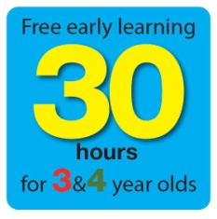

Who qualifies?
All 3 and 4 year olds in England are entitled to 570 hours free childcare per year which is usually taken as 15 hours a week for 38 weeks of the year, but you can choose to take fewer hours over more weeks depending on the setting you use.

When can a child start?
The child can have their place from the term after they turn 3. The chart shows you the cut-off dates for each term:
If your child is born between: | They will get their free place:
1st January and 31st March | Summer term (after Easter - normally April)
1st April and 31st August | Autumn term (in September)
1st September and 31st December | Spring term (in January)

30 Hours Childcare
30 hours childcare for three and four year olds is now available. This doubles the existing 15 hours currently available and could save working families up to £5,000 a year.
Parents will be able to check their eligibility and apply now using the online childcare calculator here https://www.childcarechoices.gov.uk/. Once signed up, parents will receive an eligibility code to take to their childcare provider. Childcare providers will then check the code with their local authority. If eligible, parents can book their 30 hours place.
As you will be aware, parents are required to reconfirm that they remain eligible for 30 hours every 3 months. If a parent’s details have not changed, they only need to tick a box in their childcare service account to confirm their details remain the same.
What can you do to help the parent?
Ring Families Information Service on: 01922 653383
Give them a sticker with the number on

